**SAP BW/BO Exercise**

**Exercise 12: Crystal Reports**

**Student Name: Manish Bordoloi Student Id: 2021244262**

**Date: 07/31/2015 SAP ERP Login Id: M5UTD-005**

**Objective**

The exercise is designed to help the student acquire the ability to

1. Merge three reports and make a single drilldown report.
2. Create a report of sales with respect to country.
3. Drilldown the sales report with respect to sales organization.
4. Further drilldown of the sales per month.
5. Open Crystal reports tool.
6. Click on File -> New -> Standard report
7. Expand ‘Create new connections’ in ‘Standard report creation wizard’
8. Click on ‘Database Files’. This would allow you to browse the file, choose the data set provided in the exercise.
9. You’ll see that the data set is now uploaded into the tool.

Select the Data$ and get it to the selected tables columns on the right hand side by clicking on “>” button in the middle. Click on the Next button.

1. Select all the fields that have to be displayed in the report And Click on the Next button.

(Click on >> button)

1. Here is the place you are trying to group the report. First select country and send it to Group by column on the right side, then the sales organization and then the calendar month. Click on the Next button.
2. **Paste the screenshot of the grouping window.**

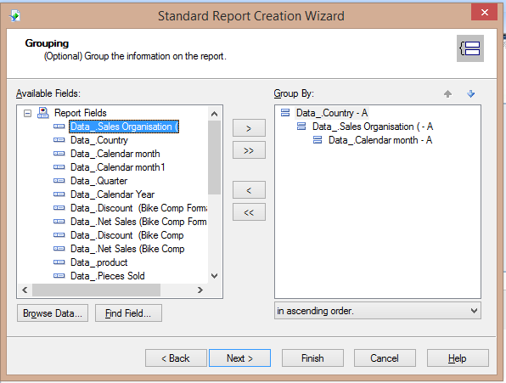

1. In this step the data that has to be summarized will be selected. Click on the Next button.
2. In the Grouping screen select ‘group that will sorted’ as calendar month as shown below.

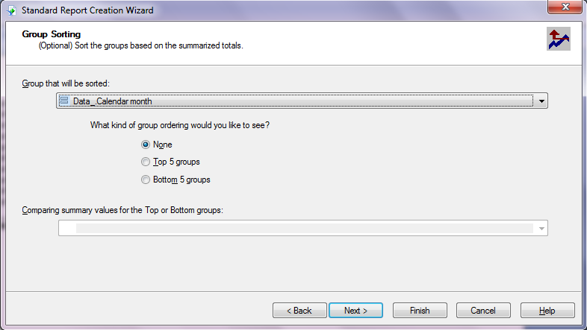

1. Select the Type of chart you would like to display.

Choose Bar Chart, Title of the chart can be changed.

In the show summary dropdown select ‘Sum of Data Net Sales’. Go to the Next Screen.

1. Click Next in the filtering and Template Screens.
2. You see the net sales per country, now copy the same graph (Ctrl+C). Double click on any of the country details say suppose Germany and paste the copied graph in this screen (Ctrl+V) and further drill down to any sales organization say Bikes studio Berlin and paste the grap’h.
3. **Paste the screen shot of the report’s initial screen.**

**(Place the answer here)**

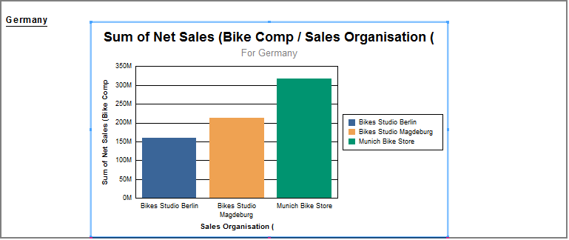

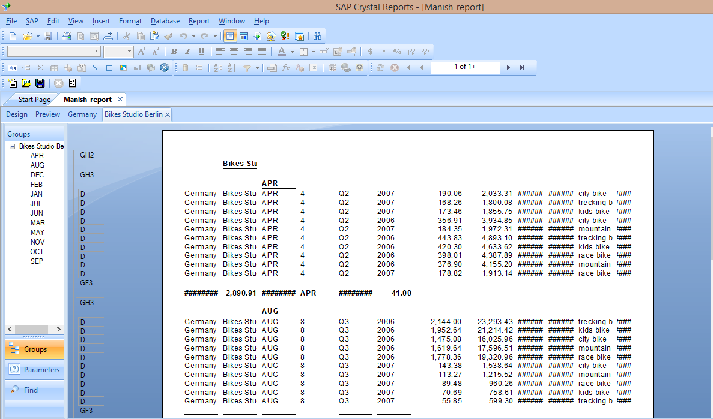

1. Now the Save the report, Observe that the complete report gives the details of the countries, their sales organizations and the monthly sales in them.

* To see the different sales organizations in a country go to the preview tab of the report, double click on the country graph.
* Similarly to see the monthly statistics of a sales organization in a particular country go to preview tab double click on the respective country graph and then double click on the sales organization.
* To see the sales in a particular month now double click on the month.

**Answer the following based on your report**

1. **Which month had the highest sales in Bikes Studio Magdeburg of Germany?**

* **August**

1. **Paste the screen shot of the sales of April in Melbourne of Australia.**

